

AI-Powered Quick Food Delivery System in Georgia

Author: Sai Sri Rag Badveti

This is proved by the Bachelor's Project Committee of the School of Science and Technology of the University of Georgia

Supervisor:
Bekar Meladze

Tbilisi
13 November 2026

Abstract
Quick commerce, the delivery of groceries and everyday items within minutes from small urban warehouses called dark stores, is spreading worldwide, yet in Tbilisi the leading platforms still promise delivery in about twenty to thirty minutes. This project designs and evaluates an AI-powered quick food delivery system for Tbilisi with a ten-minute service target, built on the principle that speed must come from planning rather than from pressure on couriers. This preliminary report presents the technical design and the first working prototype. The prototype builds service zones on the real OpenStreetMap road network of Tbilisi, using Uber's H3 hexagonal grid; chooses dark-store locations by maximum coverage; forecasts demand per hexagon and fifteen-minute slot with a TensorFlow.js neural network that uses real Open-Meteo weather, holidays and football matches; offers the ten-minute promise only when the ninetieth percentile of the predicted delivery time fits; and assigns orders to couriers every thirty seconds with Google OR-Tools. The components run as JavaScript and Python services and are evaluated in a SimPy discrete-event simulation of a day of deliveries. The report documents the implementation with source-code listings of the main components, execution examples with sample inputs, outputs and screenshots, automated tests, and a public Git repository with build and run instructions. In the simulation, optimised assignment delivered 3.6 to 4.3 percentage points more orders within ten minutes than nearest-courier dispatch on normal days and 17.1 to 25.0 points more on match and rainy days; the forecaster reduced the store-hour forecast error by 24 percent compared with a seasonal naive forecast; and forecast-driven staffing improved the evening peak on high-demand days without extra courier hours. The results are preliminary and rest on synthetic orders and assumed congestion factors; the final stage adds traffic-aware travel times, order batching, the database and the customer, courier and operations applications.
Keywords: quick commerce, dark store, service zone, H3, demand forecasting, TensorFlow.js, order assignment, OR-Tools, discrete-event simulation, Tbilisi.

აბსტრაქტი
სწრაფი კომერცია გულისხმობს სურსათისა და ყოველდღიური პროდუქტების მიწოდებას რამდენიმე წუთში მცირე ქალაქური საწყობებიდან, ე.წ. ბნელი მაღაზიებიდან. თბილისში წამყვანი პლატფორმები მიწოდებას ჯერ კიდევ ოცი-ოცდაათი წუთის განმავლობაში ჰპირდებიან. პროექტი ავითარებს ხელოვნურ ინტელექტზე დაფუძნებულ სწრაფი მიწოდების სისტემას თბილისისთვის, რომლის მიზანია ათწუთიანი მიწოდება, ხოლო სისწრაფე მიიღწევა დაგეგმვით და არა კურიერებზე ზეწოლით. წინამდებარე წინასწარი ანგარიში წარმოადგენს ტექნიკურ დიზაინსა და პირველ მოქმედ პროტოტიპს. პროტოტიპი აგებს მომსახურების ზონებს თბილისის რეალურ საგზაო ქსელზე (OpenStreetMap) H3 ექვსკუთხა ბადის გამოყენებით, ირჩევს ბნელი მაღაზიების მდებარეობას მაქსიმალური დაფარვის პრინციპით, პროგნოზირებს მოთხოვნას TensorFlow.js ნეირონული ქსელით რეალური ამინდის, დღესასწაულებისა და ფეხბურთის მატჩების გათვალისწინებით, ათწუთიან დაპირებას სთავაზობს მხოლოდ რეალისტურ შემთხვევაში და შეკვეთებს კურიერებზე ანაწილებს Google OR-Tools-ის საშუალებით. სისტემა შეფასებულია SimPy სიმულაციით. ანგარიში ასევე წარმოადგენს ძირითადი კომპონენტების წყაროს კოდს, შესრულების მაგალითებს შემავალი და გამომავალი მონაცემებითა და ეკრანის ანაბეჭდებით, ავტომატურ ტესტებს და Git რეპოზიტორიუმს აწყობისა და გაშვების ინსტრუქციებით. სიმულაციაში ოპტიმიზებულმა განაწილებამ ათ წუთში მიწოდებული შეკვეთების წილი ჩვეულებრივ დღეებში 3.6–4.3 პროცენტული პუნქტით, ხოლო მატჩისა და წვიმიან დღეებში 17.1–25.0 პუნქტით გაზარდა, ხოლო პროგნოზის ცდომილება 24 პროცენტით შემცირდა. შედეგები წინასწარია და ეფუძნება სინთეზურ შეკვეთებს.

Table of Contents
Introduction 6
1. Literature Review 8
1.1 Quick Commerce and Dark-Store Networks 8
1.2 Service Zones, Spatial Grids and Facility Location 8
1.3 Road Networks and Travel-Time Estimation 8
1.4 Demand Forecasting with Weather and Event Signals 9
1.5 Dynamic Order Dispatching 9
1.6 Simulation of Delivery Systems 9
1.7 Research Gap 9
2. Brief Market Research 11
3. Technical Design 12
3.1 System Architecture and Implementation Status 12
3.2 Data Sources and Pipeline 13
3.3 Road Graph, Service Zones and Store Siting 13
3.4 Demand Model and Forecasting 14
3.5 Delivery Promise Engine 14
3.6 Order Allocation and the OR-Tools Solver 15
3.7 Simulator 15
3.8 Service Interfaces 15
4. Methodology 17
4.1 Research Approach 17
4.2 Experiments 17
4.3 Metrics and Statistical Analysis 17
5. Software Implementation 18
5.1 Repository, Build and Run Instructions 18
5.2 Service Zones and Road-Network Routing 19
5.3 AI Demand Forecasting Model 21
5.4 Delivery Promise Engine 23
5.5 Order Allocation Algorithm and Solver 26
5.6 Simulation Module 28
5.7 Automated Tests 30
6. Interim Results 31
6.1 Service Zones and Dark-Store Siting 31
6.2 Demand Forecasting 32
6.3 Optimised Assignment Compared with Nearest-Courier Dispatch 33
6.4 Forecast-Driven Staffing 34
6.5 Status of the Hypotheses 35
7. Remaining Work 36
Conclusion 37
References 38

Introduction

Relevance of the Topic
Online grocery and food delivery has become part of everyday life in Georgia, and Tbilisi, with 1,369.4 thousand residents on 1 January 2026 out of a national population of 3,941.1 thousand (Geostat, 2026), is the natural place for faster delivery models. Glovo and Wolt already operate dark stores in Tbilisi, but their public promises remain at about twenty minutes for Wolt Market (Entrepreneur Georgia, 2025) and within thirty minutes for Glovo (CBW, n.d.-b). In India and Turkey, quick-commerce companies built their brands on ten-minute delivery from dark stores located about two kilometres from customers (McKinsey & Company, 2022; Nanwani, Raj, & Prabhu, 2022). The experience of India also showed the cost of such promises: in January 2026 the Indian Labour Ministry intervened over rider safety, and Blinkit, Zepto and Swiggy dropped their ten-minute branding (Outlook Business, 2026). A ten-minute system for Tbilisi is therefore relevant only if the time is saved by better prediction and optimisation, not by faster riding. Forecasting demand, choosing store locations, defining realistic delivery zones and assigning orders are well-studied problems in machine learning and operations research, which makes the topic a suitable bachelor's project in information technology with a concrete software product as its outcome.

Problem Statement
Simple dispatching rules, such as giving each order to the nearest free courier, and broad delivery estimates work when the promise is thirty minutes, but at ten minutes every lost minute matters: a poor courier assignment, an unexpected peak, an unrealistic promise or an inaccurate travel time can consume a large part of the budget. Tbilisi adds its own difficulties: hilly districts, a river crossed by a limited number of bridges, congested main roads in the evening and demand peaks around events such as national football matches at the Boris Paichadze Dinamo Arena. The problem addressed by the project is how to design a delivery system that keeps a ten-minute promise reliably inside defined zones in Tbilisi while remaining honest with customers and safe for couriers.

Aim and Objectives
The aim of the project is to design, build and evaluate a prototype of an AI-powered quick-commerce system for Tbilisi that delivers groceries and ready-to-eat items from dark stores within ten minutes for customers inside each store's service zone. The objectives are to define service zones as polygons built from real road-network travel times, with an H3 hexagonal grid for measuring demand; to forecast demand per hexagon and fifteen-minute slot; to offer the ten-minute promise only when it is realistic; to assign orders to couriers with optimisation; to plan stock and courier shifts around events; and to integrate these components into a working product evaluated in a simulation of Tbilisi.

Research Question and Hypotheses
The main research question is to what extent artificial intelligence methods for forecasting, promising and dispatching can increase the share of orders in Tbilisi delivered within ten minutes without increasing the speed required from couriers. Hypothesis one states that optimisation-based assignment delivers a higher share of orders within ten minutes than nearest-courier assignment under identical demand and staffing. Hypothesis two states that a demand forecast using weather, holiday and event information is more accurate than a seasonal naive forecast. Hypothesis three states that staffing planned from the forecast reduces late deliveries on event and rainy days compared with staffing planned from historical averages, with the same total courier hours and without faster riding.

Progress Since the Concept Stage
Since the concept defence, the project has moved from design to a working prototype. Following the decisions taken at the concept stage, the AI services are written in JavaScript and TypeScript, while Google OR-Tools and SimPy are used through small Python components. Service zones follow the approach of Zepto, a polygon per dark store, but are generated from data. Travel times now come from the real OpenStreetMap road network of Tbilisi instead of straight-line estimates, real hourly weather for August to October 2025 replaces synthetic weather, and dark-store locations are chosen by an optimisation algorithm instead of by hand. The source code is maintained in a Git repository, and all figures and tables in this report are produced by its scripts. Chapter 5 documents the implementation itself: the source code of the main components, how to build and run them, and execution examples with real inputs, outputs and screenshots.

Scope and Limitations
The project covers Tbilisi and dark-store delivery of groceries, drinks, snacks, household items and packaged ready-to-eat food; restaurant meals are excluded because cooking time alone can exceed the budget. Because delivery platforms do not publish operational data, orders are generated synthetically from public data, and the evaluation is carried out in simulation. Travel times use free-flow speeds by road class with assumed congestion factors per time band until traffic-aware times from the Google Maps Platform are added in the final stage. These limitations are stated wherever results are reported.

1. Literature Review

1.1 Quick Commerce and Dark-Store Networks
Quick commerce differs from scheduled online grocery delivery in that the platform keeps inventory in small fulfilment centres inside residential areas and delivers single orders almost immediately. Getir describes its stores as hyper-local mini warehouses stocked with around two thousand everyday items and promises delivery in ten to fifteen minutes (McKinsey & Company, 2022). Zepto has reported an average delivery distance of about 1.8 kilometres, an average rider speed of about 12 kilometres per hour and order packing in about sixty seconds, while couriers interviewed in Bangalore stated that ten-minute delivery is possible only within about four to five kilometres of a dark store (Nanwani et al., 2022). These figures show that a ten-minute promise depends far more on proximity and preparation than on riding speed. The design of the dark-store network itself has been modelled as a location routing problem: Yang, Ostermeier and Hübner (2024) show that several small micro-fulfilment centres can outperform fewer large ones on both lead time and cost, and that slightly longer lead times allow order bundling with large savings.

1.2 Service Zones, Spatial Grids and Facility Location
A study that mapped the dark stores of Indian quick-commerce platforms found that Zepto defines the delivery area of each store as a polygon of coordinates outlining its exact boundary rather than as a circle or a regular grid cell (Banga, 2026). For measuring demand inside and across such zones, mobility platforms use discrete global grids. Uber developed and open-sourced H3, a hierarchical grid of hexagonal cells, because the centre of a hexagon is at the same distance from all six neighbours, whereas a square has two different neighbour distances, which simplifies smoothing and neighbourhood search and reduces distortion when people move between cells (Brodsky, 2018). Square-cell systems such as Google's S2 offer exact hierarchical nesting, which matters for indexing at global scale more than for a single city. Choosing where to place stores so that as many residents as possible are within a given travel time is the classical maximal covering location problem (Church & ReVelle, 1974), for which greedy algorithms that repeatedly add the location with the largest additional coverage are a standard and effective approach.

1.3 Road Networks and Travel-Time Estimation
Travel times on a road network are computed with shortest-path algorithms, the best known being Dijkstra's algorithm (Dijkstra, 1959). OpenStreetMap provides a free, community-maintained road network of most cities in the world, including road classes and one-way restrictions (Haklay & Weber, 2008). Free-flow travel times ignore traffic, which changes by hour and day; Derrow-Pinion et al. (2021) describe how Google Maps predicts travel times from historical and live traffic with graph neural networks, and the Google Maps Platform Routes API makes such traffic-aware estimates available for up to 625 origin-destination pairs per request (Google, n.d.). This project uses the OpenStreetMap network with Dijkstra's algorithm at the preliminary stage and plans to calibrate it with traffic-aware times from the Routes API.

1.4 Demand Forecasting with Weather and Event Signals
Hyndman and Athanasopoulos (2021) recommend comparing any forecasting model with simple benchmarks such as the seasonal naive method, which repeats the value from one season earlier. For problems with many explanatory variables, gradient-boosted trees such as LightGBM (Ke et al., 2017) and decomposable models such as Prophet (Taylor & Letham, 2018) are common choices, while neural networks can be trained and served in JavaScript with TensorFlow.js (Smilkov et al., 2019). Special events are a known source of error in urban demand; Rodrigues, Markou and Pereira (2019) show that taxi demand near event venues is predicted more accurately when time series are combined with information about scheduled events. Count data such as orders per interval are usually modelled with a Poisson likelihood, and predicting a multiplier on a seasonal level is a common way to let a model learn deviations from a stable baseline.

1.5 Dynamic Order Dispatching
Assigning delivery orders to couriers is a dynamic vehicle routing problem (Pillac, Gendreau, Guéret, & Medaglia, 2013; Toth & Vigo, 2014). The meal delivery routing problem of Reyes, Erera, Savelsbergh, Sahasrabudhe and O'Neil (2018) assigns orders with tight targets to couriers in rolling time windows and allows bundling, and Ulmer, Thomas, Campbell and Woyak (2021) show that briefly delaying some decisions can improve overall service. In ride-hailing, Xu et al. (2018) show at large scale that solving a bipartite matching between waiting requests and drivers in short batching windows outperforms greedy nearest-driver assignment. The underlying assignment problem is solved exactly by the Hungarian method (Kuhn, 1955) and by solvers such as Google OR-Tools (Perron & Furnon, 2024). Surge pricing can prevent inefficient matching when demand exceeds supply (Castillo, Knoepfle, & Weyl, 2017), but this project limits pricing to a small capped delivery fee and handles peaks mainly through planning.

1.6 Simulation of Delivery Systems
Discrete-event simulation models a system as a sequence of events, such as an order arriving or a courier returning, and is the standard method for evaluating operational policies that cannot be tested on a live system (Law, 2015). Because policies can be compared on exactly the same random demand, simulation supports paired statistical comparisons. SimPy is an open-source discrete-event simulation library for Python based on processes and shared resources (Team SimPy, n.d.).

1.7 Research Gap
The literature offers mature methods for each part of the problem, namely store location, zones, travel times, forecasting and dispatching, but rarely combines them in one system designed around an explicit ten-minute target, and no published work applies them to the Georgian market. Most studies use large flat cities with abundant data. This project integrates these methods into one working prototype for Tbilisi, uses its real road network and weather, and evaluates the result explicitly against the requirement that couriers should not need to ride faster.

2. Brief Market Research
The Georgian delivery market is led by three international platforms. Wolt and Glovo entered Georgia around 2018, and Bolt Food launched in Tbilisi during the COVID-19 pandemic. Glovo Georgia reported a 64 percent increase in e-commerce turnover in 2022 and works with more than two thousand partner businesses and more than three thousand couriers (Gorkhelashvili, 2023). Glovo opened its first dark store in Tbilisi as part of its Cook Room project (CBW, n.d.-a), and Wolt Market operates several dark stores in Tbilisi with more than five thousand products (Entrepreneur Georgia, 2025). Table N 1 summarises the publicly stated offers.
Table N 1.
Quick-commerce offers of the main delivery platforms in Tbilisi
Platform | Quick-commerce format | Publicly stated delivery time
Glovo | Dark stores and partner supermarkets | Within 30 minutes
Wolt | Wolt Market dark stores, more than 5,000 products | About 20 minutes on average
Bolt Food | Mainly restaurant and partner-store delivery | No quick-commerce promise found
Proposed system | AI-planned dark stores with road-network zones | 10 minutes inside the zone; honest estimate outside
Source: compiled by the author from CBW (n.d.-a, n.d.-b), Entrepreneur Georgia (2025) and Gorkhelashvili (2023).
The target users are residents of dense districts who need a few items quickly, such as students, young professionals, families with small children and the large community of international students and foreign residents. Demand is expected to peak in the evening, at weekends, in bad weather and around football matches and holidays. Local conditions shape the design: elevation differences between districts slow riding uphill, the Mtkvari river limits crossings, main roads are congested in the evening, large apartment blocks lengthen the handover at the door, and many customers pay in cash. No platform in Tbilisi currently offers a reliable ten-minute promise, which supports the market relevance of the project.

3. Technical Design

3.1 System Architecture and Implementation Status
The system follows a layered architecture, shown in Figure N 1 together with the implementation status at the preliminary stage. The AI services are Node.js services written in TypeScript: the service-zone builder, the demand forecasting service based on TensorFlow.js, the delivery promise engine, the event-aware planner and the order allocation service. Optimisation is delegated to Google OR-Tools, which has no JavaScript version and therefore runs in a small Python service built with FastAPI, and the SimPy simulator used for evaluation is also written in Python. The presentation layer and the core backend with PostgreSQL and PostGIS are planned for the final stage; at this stage the services read the generated data files directly.
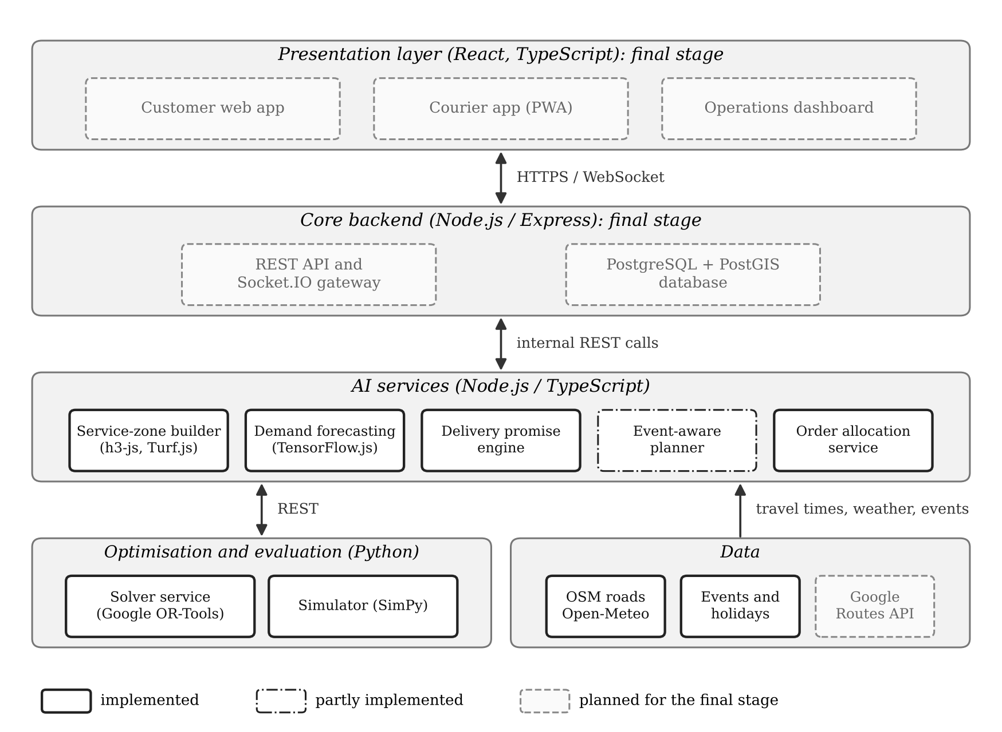
Figure N 1.
System architecture and implementation status at the preliminary stage (created by the author)
Table N 2 lists the components of the repository with the technology of each and its status. All components are reproducible from the repository with documented commands, and automated tests cover the promise engine and the assignment solver.
Table N 2.
Components of the prototype
Component | Technology | Status
Road graph and service zones | TypeScript, h3-js, Turf.js, OpenStreetMap | Implemented
Dark-store siting | TypeScript, greedy maximum coverage | Implemented
Demand generator | TypeScript, Open-Meteo weather | Implemented
Demand forecasting | TypeScript, TensorFlow.js | Implemented
Delivery promise engine | TypeScript, Express (REST) | Implemented, tested
Order allocation service | TypeScript, Express (REST) | Implemented
Assignment solver | Python, FastAPI, Google OR-Tools | Implemented, tested
Simulator and experiments | Python, SimPy | Implemented
Operations demo console | HTML, SVG, JavaScript | Prototype
Event planner | Forecast-driven staffing | Partly: staffing done, fee rule planned
Backend, database, apps | Node.js, PostgreSQL, PostGIS, React | Final stage
Source: created by the author.

3.2 Data Sources and Pipeline
The road network was taken from the Geofabrik extract of OpenStreetMap for Georgia (Geofabrik, 2026) and reduced with a Python script to the roads of Tbilisi, giving 38,359 road ways with their class and one-way attributes. Hourly temperature and precipitation for Tbilisi from August to October 2025 come from the Open-Meteo historical weather service (Zippenfenig, 2023); the period contains 216 hours with precipitation and 184 millimetres of rain. District populations from the 2014 census (Brinkhoff, n.d.) were scaled to the 2026 total of Geostat and spread evenly over the H3 cells nearest to each district centre, which approximates district borders. A calendar of Georgian public holidays and seven home matches at the Dinamo Arena, three of them national-team matches, completes the inputs. The pipeline runs in four steps: siting the stores, building zones and travel-time tables, generating twelve weeks of order history, and training the forecaster.

3.3 Road Graph, Service Zones and Store Siting
The road graph contains 178,261 nodes and 357,943 directed edges with about 4,470 kilometres of road. Each edge receives a free-flow riding time for a moped or electric scooter from its road class, from 14 kilometres per hour on service roads and 20 on residential streets to 34 on primary roads, and one-way streets are respected. Travel times between a store and the centre of every H3 cell at resolution 9, each cell covering about a tenth of a square kilometre, are computed with Dijkstra's algorithm on the largest connected part of the graph and multiplied by an assumed congestion factor per time band: 1.10 in the morning, 1.05 at midday, 1.30 in the evening peak, 0.95 at night and 1.05 at weekends. The cells reachable within seven minutes of riding form the zone; they are merged with h3-js and smoothed with Turf.js into one polygon per store and time band, so that every zone shrinks in the evening peak.
Store locations are chosen by greedy maximum coverage. The candidates for each store are the populated cells of its district within 2.5 kilometres of the district centre, between 115 and 144 candidates per store. Stores are placed one at a time, and each takes the candidate whose seven-minute midday zone adds the most residents not yet covered by the stores placed before it. This step replaced the locations guessed by hand at the concept stage.

3.4 Demand Model and Forecasting
The expected number of orders in a cell and fifteen-minute slot is the product of the cell's residents, a per-capita order rate, a time-of-day profile that differs between weekdays and weekends, a day-of-week factor, a rain factor of six percent per millimetre of hourly precipitation up to eight millimetres, a holiday factor of fifteen percent and a match factor. The match factor rises before kick-off, at half-time and after the match, scales with attendance and decreases with distance from the stadium, with a smaller city-wide effect for national-team matches. An unobserved random effect per store and day, with a standard deviation of eight percent, makes the series realistic and not perfectly predictable. Actual orders are drawn from a Poisson distribution. The per-capita rate was calibrated so that the three stores receive on average 819, 619 and 260 orders per day.
The forecaster predicts orders per cell and slot from 31 inputs: time of day, day of week, holiday and weekend flags, temperature and precipitation, the cell's recent demand and that of its neighbouring hexagons relative to a seasonal level, the cell's population, match indicators, attendance and distance-weighted event intensities, and the store. The seasonal level is the mean demand of the same cell and neighbouring slots over up to four previous same weekdays without matches or holidays, blended with the store-level pattern. A feed-forward network with two hidden layers of 32 and 16 units predicts a log-multiplier m on this level, so that the forecast is the level multiplied by the exponential of m, and it is trained with a Poisson likelihood using the Adam optimiser. The model is trained on 960,512 cell-slot observations from 11 August to 5 October 2025 and tested on 360,192 observations from 6 to 26 October 2025.

3.5 Delivery Promise Engine
The promise engine models the total delivery time as the sum of picking time, waiting time for a courier, riding time and handover time. Picking follows a lognormal distribution with a median of 1.4 minutes, the waiting time is the expected wait at the store multiplied by a lognormal error, the riding time is the stored travel time for the store, cell and time band multiplied by a lognormal error with a spread of eighteen percent, and the handover takes on average 0.8 minutes. The engine draws 400 samples and offers the ten-minute promise only if the address is inside the zone and the ninetieth percentile is at most ten minutes; otherwise it promises the next five-minute step above the ninetieth percentile. Results are deterministic for the same inputs, which the automated tests verify.

3.6 Order Allocation and the OR-Tools Solver
Every thirty seconds the allocation service collects the waiting orders and the couriers who are free or return within two minutes, at all three stores. It builds a matrix in which each row is an order and each column is a courier or a defer option for that order. The cost of giving an order to a courier is the predicted age of the order at delivery plus four times any minutes beyond its promise, plus a small penalty if the courier must first move to another store. The cost of deferring is the best cost the order could reach in the next round plus a deferral penalty, so that scarce couriers go to the most urgent orders rather than the freshest ones. The Python service solves the matrix exactly with the linear sum assignment solver of Google OR-Tools, a Hungarian-type algorithm, and returns the matches.

3.7 Simulator
The simulator, written with SimPy, reproduces a day from 08:00 to midnight. Orders are drawn for every cell and slot from the scenario's expected demand, picked, promised by calling the promise engine and dispatched. In the baseline policy, a ready order goes to the first free courier of its own store in order of arrival. In the AI policy, the simulator calls the allocation service every thirty seconds, which in turn calls the OR-Tools solver, so the evaluated logic is the product code itself. Couriers ride at the stored travel times with random variation, hand over the order and return to their store. Staffing per store and hour is either fixed, derived from the historical average for the type of day, or forecast-driven, derived from the forecast for that day and rescaled to the same total courier hours. In both cases the number of couriers for an hour is the expected orders multiplied by the average round-trip time of that hour, divided by sixty and by a target utilisation of eighty percent, with a minimum of two couriers.

3.8 Service Interfaces
Table N 3 summarises the REST interfaces of the services. The interfaces are deliberately small so that the backend of the final stage can call the same services that the simulator calls today.
Table N 3.
REST interfaces of the services
Service | Endpoint | Input and output
Promise engine (:4002) | POST /promise | Store, H3 cell, time band, expected wait; returns promised minutes, P50, P90 and whether 10 minutes is offered
Promise engine (:4002) | POST /promise/batch | List of the above, used by the simulator
Allocation (:4003) | POST /assign | Current time, time band, waiting orders, available couriers; returns order-courier assignments
Solver (:5001) | POST /assign | Cost matrix with defer options; returns the optimal column for every row
All services | GET /health | Service status
Source: created by the author.

4. Methodology

4.1 Research Approach
The project follows design science research, in which knowledge is produced by building an artefact for a relevant problem and evaluating it rigorously (Hevner, March, Park, & Ram, 2004). The artefact is the prototype described in Chapter 3; relevance comes from the market gap described in Chapter 2, and rigour from grounding each component in established methods and comparing it with explicit baselines in controlled experiments.

4.2 Experiments
Experiment one tests the first hypothesis by comparing the baseline and AI dispatch policies with fixed staffing on four scenario days: a dry weekday (21 October 2025), a rainy weekday with six millimetres of rain per hour from 16:00 to 23:00 (23 October 2025), a dry Saturday (25 October 2025) and a weekday with a national-team match kicking off at 20:00 (15 October 2025). Experiment two tests the second hypothesis by comparing the forecaster with the seasonal naive forecast over the three test weeks. Experiment three tests the third hypothesis by comparing fixed and forecast-driven staffing on the rainy and match days with the AI dispatch policy. Each simulated configuration is run with twenty random seeds, and the same seed gives identical orders, picking times and riding variations to both compared policies, which allows paired comparison.

4.3 Metrics and Statistical Analysis
The main metric is the share of orders delivered within ten minutes of being placed, reported for the whole day and for the evening peak from 17:00 to 21:00. Supporting metrics are the mean and ninetieth-percentile delivery time, the share of promises kept, the share of ten-minute promises kept, the waiting time for a courier and orders per courier hour. Forecast accuracy is measured by the weighted absolute percentage error, the sum of absolute errors divided by the sum of actual orders, at the level of store and hour, which is the level used for staffing. Differences between policies are reported as the mean of the paired differences across seeds with a 95 percent confidence interval. Riding speeds are an input of the simulation and are identical across policies, so any improvement in the results comes from planning and assignment and not from faster riding.

5. Software Implementation
This chapter presents the implemented software: the repository and how to build and run it, the source code of the main components with an explanation of how each works, and execution examples with real inputs, outputs and screenshots. The listings are abridged excerpts of the repository files, wrapped to the width of the page, and omitted lines are marked with three dots in a comment. The terminal screenshots were captured from runs of the code in the repository, and the numbers in them are the same as those used in the rest of the report.

5.1 Repository, Build and Run Instructions
The complete source code, data extracts, results and this report are kept in the Git repository at https://github.com/Sriragbadveti/ai-quick-delivery-georgia. The repository is a monorepo: the Node.js components are npm workspaces under the packages folder, and the two Python components have their own folders. Table N 4 describes the structure. The software requires Node.js version 20 or later and Python version 3.10 or later; no graphics card is needed, and all steps run on an ordinary laptop. The road-network extract and the weather file are included in the repository, so the original Geofabrik file is needed only to regenerate the extract.
Table N 4.
Structure of the repository
Folder | Contents
packages/geo | Road graph, travel-time providers, dark-store siting, service-zone builder (TypeScript)
packages/demand | Synthetic demand generator, TensorFlow.js forecaster, forecast inspection command
packages/promise | Delivery promise engine, REST service and the demo console page
packages/allocation | Cost matrix and REST service for order allocation
solver | FastAPI service with the OR-Tools assignment solver and its tests
simulator | SimPy simulator and the experiment runner
config | City configuration, district populations, stadium, sited dark stores
data/raw | Tbilisi road extract (OpenStreetMap) and hourly weather (Open-Meteo)
scripts, results, docs | Service launcher, extraction and figure scripts; result files and figures; this report
Source: created by the author.
Table N 5 lists the commands for building and running the project from a fresh copy of the repository, in the order in which they are used. Each step writes its output to the data/generated or results folders, which the following steps read.
Table N 5.
Build and run commands
Step | Command | Result
1. Install | npm install; pip install -r requirements.txt | Node.js and Python dependencies
2. Site the stores | npx tsx packages/geo/src/siteStores.ts | config/stores.sited.json
3. Build zones | npx tsx packages/geo/src/buildZones.ts | Zones and travel-time tables
4. Generate demand | npx tsx packages/demand/src/generate.ts | Order history and scenarios
5. Train forecaster | npx tsx packages/demand/src/forecast.ts | Forecasts and error metrics
6. Start services | ./scripts/run_services.sh | Solver :5001, promise :4002, allocation :4003
7. Demo console | Open http://localhost:4002/demo | Interactive zone map and promises
8. One simulation | python3 simulator/sim.py --scenario match --policy ai --seed 3 | Metrics of one simulated day
9. Experiments | python3 simulator/experiments.py --seeds 20 | results/sim_summary.json
10. Figures and tests | python3 scripts/figures.py; npx tsx --test packages/promise/src/engine.test.ts; pytest solver | Figures; test reports
Source: created by the author; the same instructions are given in the README file of the repository.

5.2 Service Zones and Road-Network Routing
The road graph is loaded from the Tbilisi extract into adjacency lists in which every edge stores its riding time in minutes. Listing N 1 shows the core of the routing: Dijkstra's algorithm with a binary heap computes the shortest riding time from a dark store to every node of the graph in one pass, and a reverse variant on the transposed graph gives the times towards the store. The zone builder converts these times into travel times to the centre of every H3 cell, multiplies them by the congestion factor of the time band, keeps the cells reachable within seven minutes, merges them into a polygon with h3-js and smooths the outline with Turf.js. Results are written as GeoJSON for the zones and as JSON tables for the travel times, which all other components read.
Listing N 1.
Shortest riding times and construction of a zone polygon
// packages/geo/src/roadGraph.ts: shortest riding times
dijkstra(src: number, reverse = false): Float64Array {
const adj = reverse ? this.radj : this.adj;
const dist = new Float64Array(this.lat.length)
.fill(Infinity);
dist[src] = 0;
const h = new Heap(); h.push(0, src);
while (h.size) {
const [d, u] = h.pop();
if (d > dist[u]) continue;
for (const e of adj[u]) {
const nd = d + e.min;
if (nd < dist[e.to]) { dist[e.to] = nd; h.push(nd, e.to); }
}
}
return dist;
}

// packages/geo/src/buildZones.ts: cells within 7 min -> polygon
const inZone = cells.filter(
(c) => travel[band][s.id][c] <= city.zoneRidingMinutes);
const mp = cellsToMultiPolygon(inZone, true);
let shape = turf.multiPolygon(mp);
// smooth the hexagon outline (+40 m, then -40 m)
shape = turf.buffer(turf.buffer(shape, 0.04,
{ units: "kilometers" })!, -0.04, { units: "kilometers" })!;
Source: packages/geo/src/roadGraph.ts and packages/geo/src/buildZones.ts in the project repository.
Figure N 2 shows the execution of the siting and zone-building steps. For each store the siting step prints the number of candidate cells, the residents covered by the location chosen by hand at the concept stage and the additional residents covered by the chosen location. The zone report then lists, for each store and time band, the number of H3 cells, the residents and the area of the zone, and confirms that the travel times come from the OpenStreetMap road network.
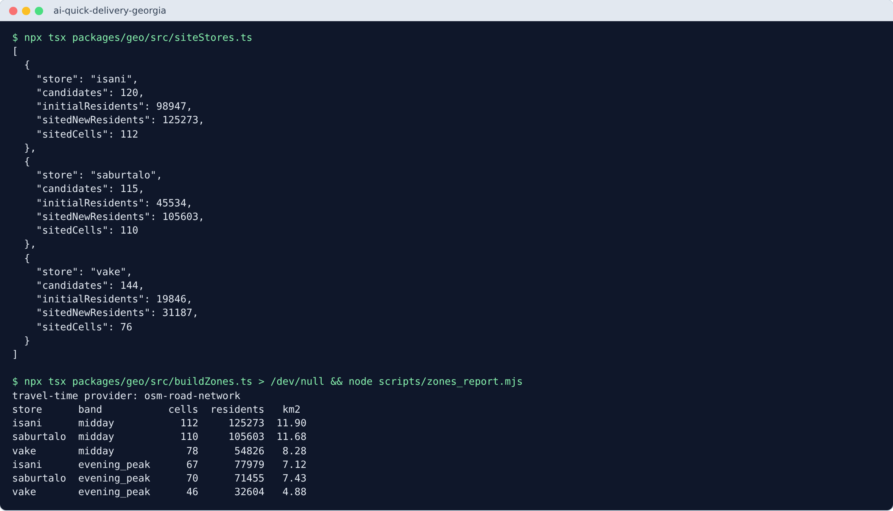
Figure N 2.
Execution of dark-store siting and zone building (screenshot of a terminal session, created by the author)

5.3 AI Demand Forecasting Model
The forecaster is implemented in TypeScript with TensorFlow.js, running on the CPU backend in Node.js. For every H3 cell and fifteen-minute slot a feature vector of 31 values is built from the calendar, the weather, the recent demand of the cell and its neighbouring hexagons, the event calendar and the store, and all features are standardised with the statistics of the training period. Listing N 2 shows the model and the training loop. Instead of predicting the number of orders directly, the network predicts a log-multiplier on a seasonal level, which keeps the forecast stable in normal periods and lets the network learn the effects of rain, holidays and matches. The custom training loop minimises the Poisson negative log-likelihood, the appropriate loss for counts, with the Adam optimiser in batches of 2,048 rows for ten epochs.
Listing N 2.
Neural network and training loop of the demand forecaster
// packages/demand/src/forecast.ts (abridged)
// forecast = seasonal level * exp(m); the network predicts m
const model = tf.sequential();
model.add(tf.layers.dense({ inputShape: [nf], units: 32,
activation: "relu" }));
model.add(tf.layers.dense({ units: 16, activation: "relu" }));
model.add(tf.layers.dense({ units: 1,
kernelInitializer: tf.initializers.zeros() }));
const opt = tf.train.adam(0.003);
for (let e = 0; e < EPOCHS; e++) {
// ... shuffle the training rows
for (let b = 0; b < order.length; b += BATCH) {
const ids = order.slice(b, b + BATCH);
const loss = tf.tidy(() => {
const xb = tf.tensor2d(ids.map((j) => Xn[j]));
const yb = tf.tensor1d(ids.map((j) => train.y[j]));
const lb = tf.tensor1d(ids.map((j) => train.lv[j]));
return opt.minimize(() => {
const m = (model.apply(xb) as tf.Tensor).reshape([-1]);
const yhat = tf.mul(lb, tf.exp(m));
// Poisson negative log-likelihood of the order counts
return tf.mean(tf.sub(yhat,
tf.mul(yb, tf.log(tf.add(yhat, 1e-6))))) as tf.Scalar;
}, true)!;
});
// ... record the mean loss of the epoch
}
}
Source: packages/demand/src/forecast.ts in the project repository.
Figure N 3 shows the stored metrics of the training run, with 960,512 training rows, 31 features, ten epochs and 216 seconds of training time, and an example of the forecast for one store and one test day, produced by the forecast inspection command. For the Saburtalo store on the normal weekday of 21 October 2025, the network's hourly forecast has an error of 11.9 percent against 18.3 percent for the seasonal naive forecast. The aggregate results over all test days are discussed in Chapter 6.
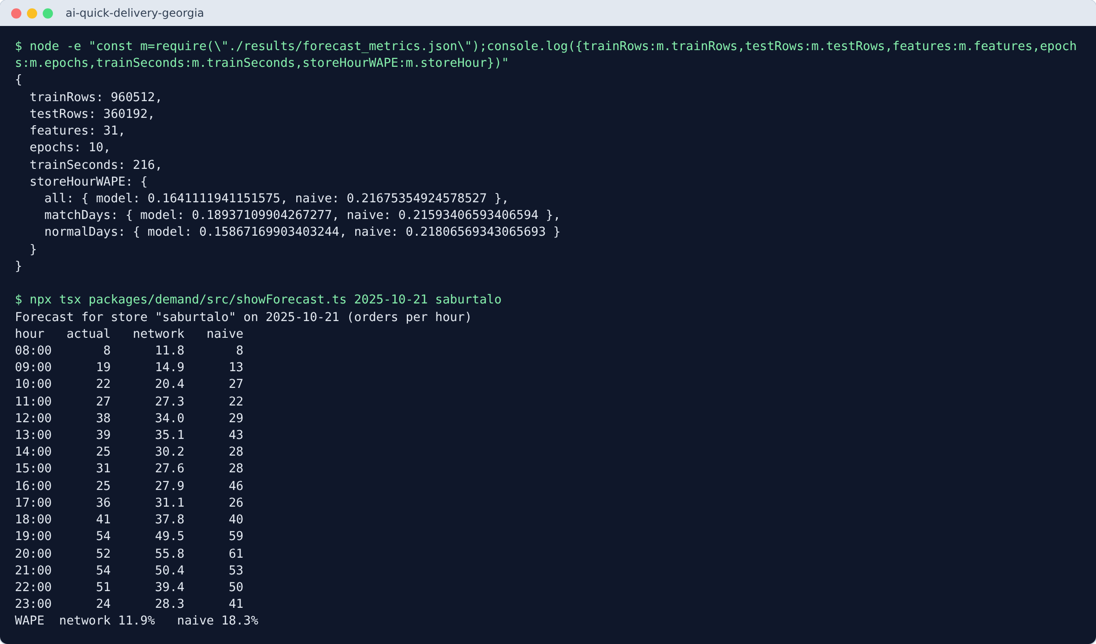
Figure N 3.
Training metrics and an hourly forecast for the Saburtalo store on 21 October 2025 (screenshot, created by the author)

5.4 Delivery Promise Engine
The promise engine is a TypeScript module exposed through an Express REST service. Listing N 3 shows its main function. For a request containing the store, the H3 cell of the address, the time band and the expected waiting time for a courier, it draws 400 samples of the total delivery time from the distributions of picking, waiting, riding and handover time, computes the median and the ninetieth percentile, and offers the ten-minute promise only if the address is inside the zone of that band and the ninetieth percentile is at most ten minutes. The random generator is seeded from the request itself, so the same request always receives the same answer, which makes the service testable and the simulation reproducible.
Listing N 3.
Main function of the delivery promise engine
// packages/promise/src/engine.ts
export function computePromise(req: PromiseRequest) {
const travel = travelMinutes(req.band, req.store, req.cell);
const inZone =
zoneSets[req.band]?.[req.store]?.has(req.cell) ?? false;
const r = mulberry(hashSeed(`${req.store}|${req.cell}|` +
`${req.band}|${req.expectedWaitMin.toFixed(2)}`));
const n = req.samples ?? 400, T: number[] = [];
for (let i = 0; i < n; i++) {
const pick = MODEL.pickMedian
* Math.exp(MODEL.pickSigma * normal(r));
const wait = req.expectedWaitMin > 0
? req.expectedWaitMin
* Math.exp(MODEL.waitSigma * normal(r))
: 0;
const ride = travel * Math.exp(MODEL.travelSigma * normal(r));
const hand = Math.max(0.2,
MODEL.handoverMean + MODEL.handoverSd * normal(r));
T.push(pick + wait + ride + hand);
}
const p50 = quantile(T, 0.5), p90 = quantile(T, MODEL.quantile);
const tenMinute = inZone && p90 <= MODEL.target;
const promisedMinutes = tenMinute
? MODEL.target : Math.max(15, Math.ceil(p90 / 5) * 5);
return { promisedMinutes, tenMinute, p50: +p50.toFixed(2),
p90: +p90.toFixed(2), travelMin: travel, inZone };
}
Source: packages/promise/src/engine.ts in the project repository.
Figure N 4 shows the three services answering their health checks and two requests to the promise engine. In the first, an address next to the Saburtalo store at midday with a free courier has a riding time of 0.65 minutes and a ninetieth percentile of 3.45 minutes, so the ten-minute promise is offered. In the second, an address at the edge of the zone in the evening peak, with three minutes of expected waiting, has a riding time of 7.62 minutes, lies outside the evening zone and has a ninetieth percentile of 16.24 minutes, so the customer is honestly promised 20 minutes.
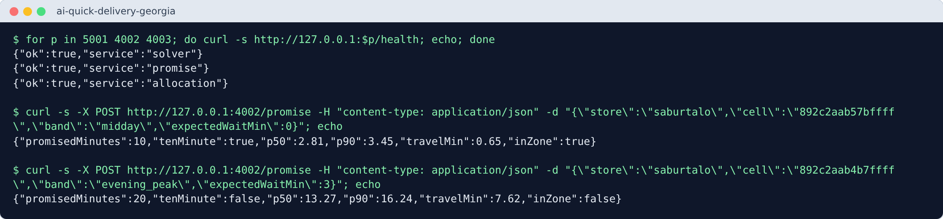
Figure N 4.
Health checks of the services and two requests to the delivery promise engine (screenshot, created by the author)
The same service also serves a demo console, a first prototype of the operations dashboard, shown in Figure N 5 and Figure N 6. The page draws the H3 cells and the zone polygons of the selected time band from the real data, and clicking a hexagon sends a request to the promise engine and displays the answer together with the raw request and response. The two screenshots reproduce the two requests of Figure N 4; in the second the zones are visibly smaller because the evening-peak band is selected.
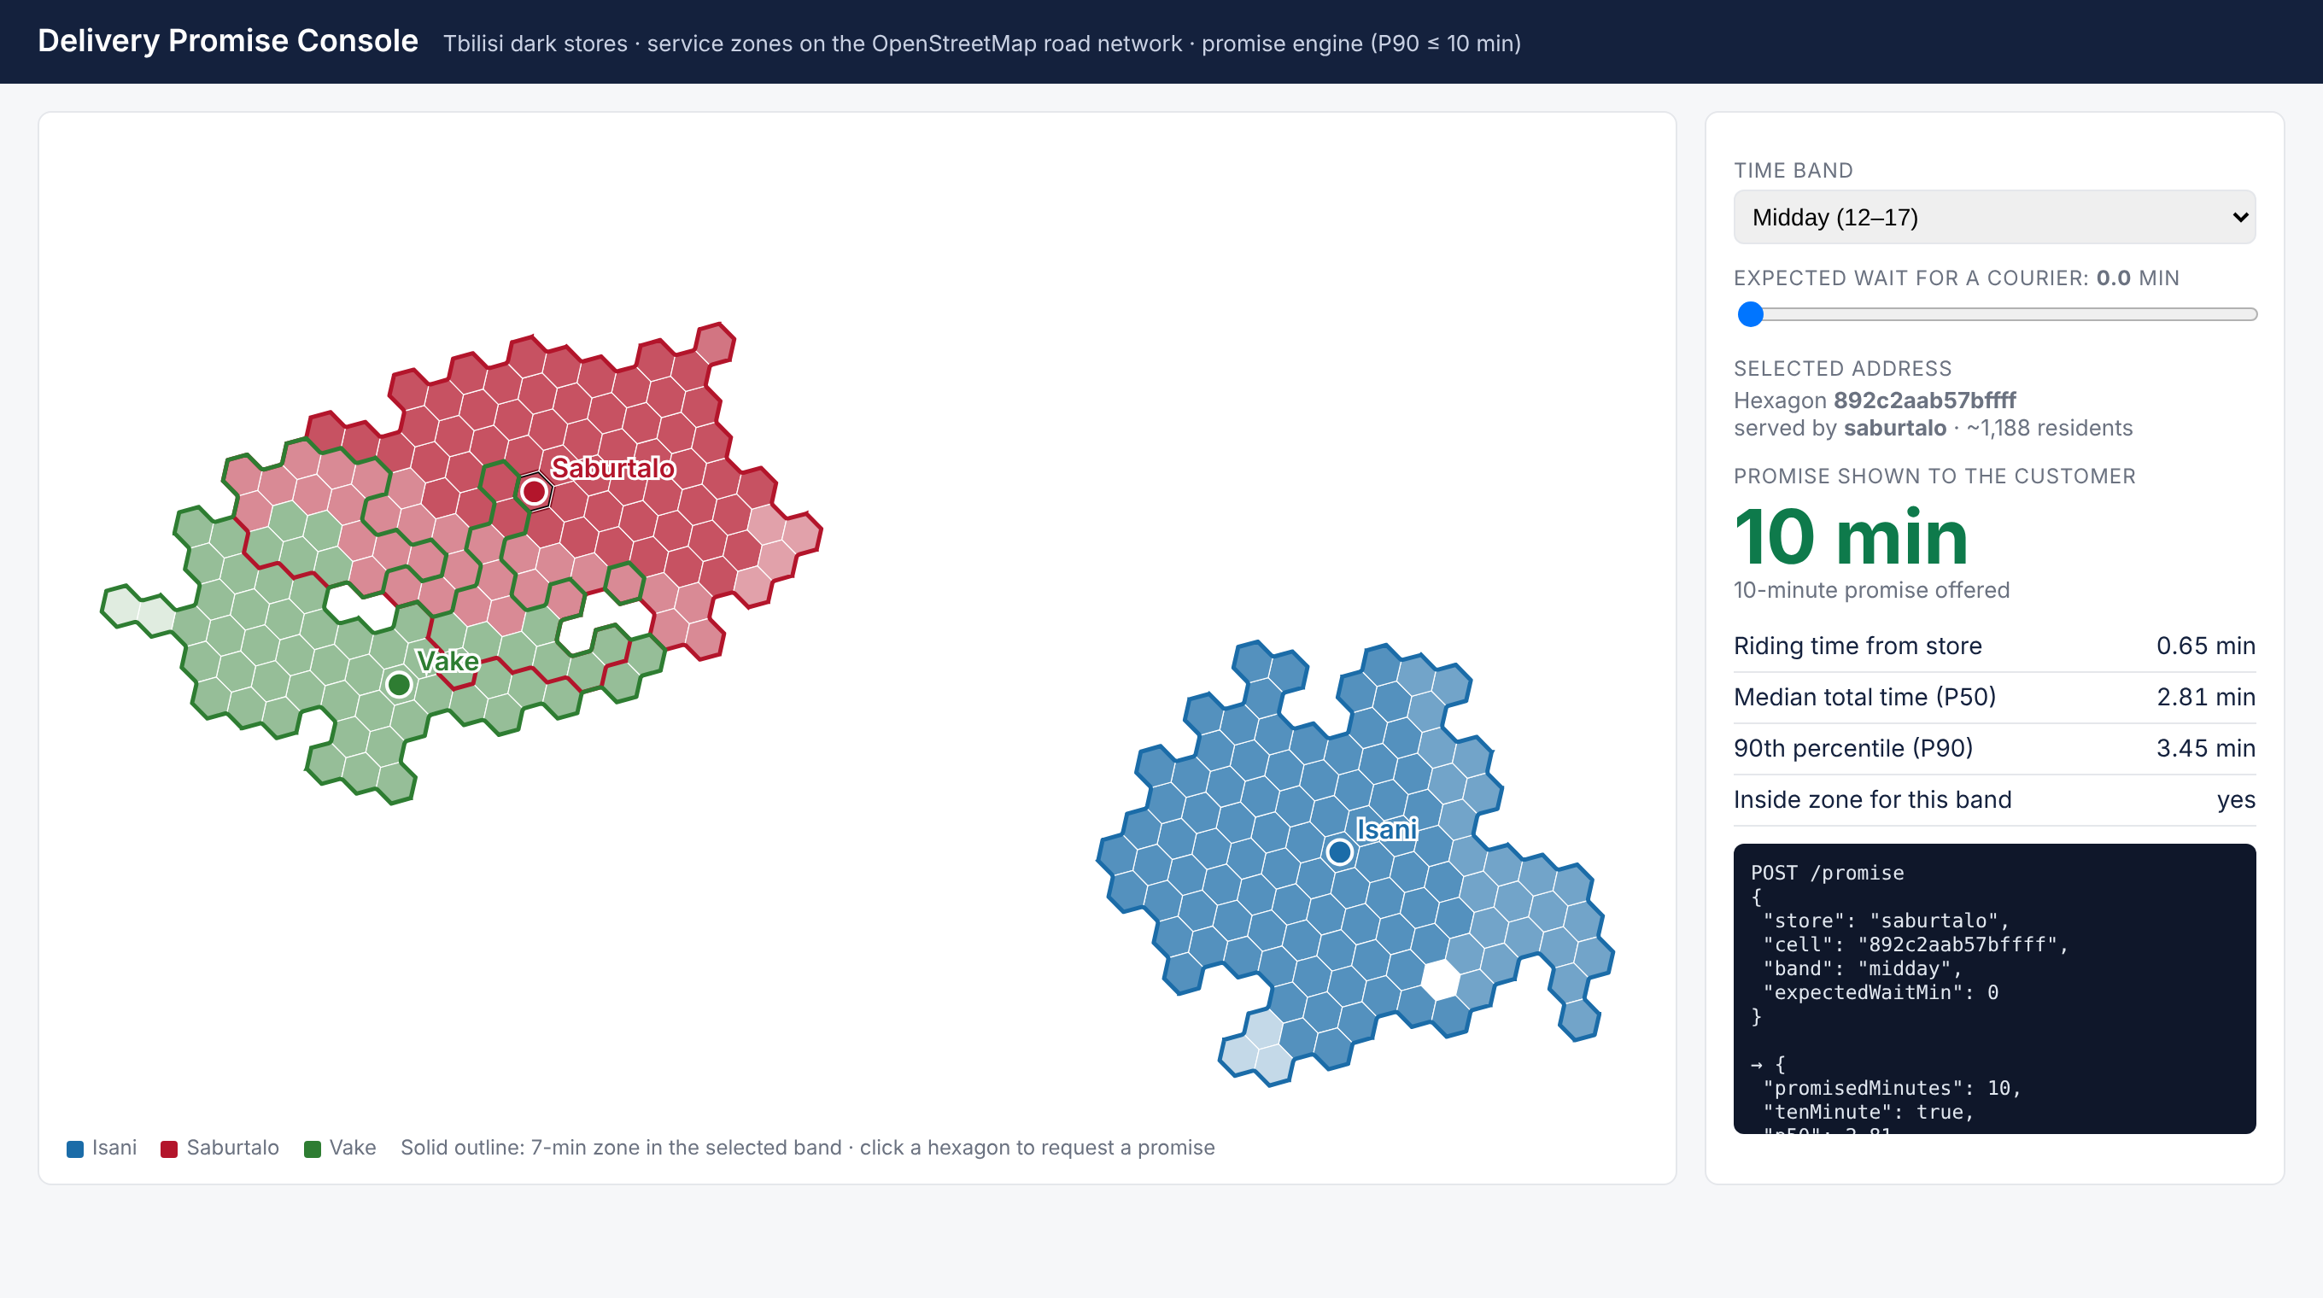
Figure N 5.
Demo console: a midday request next to the Saburtalo store receives the 10-minute promise (screenshot, created by the author)
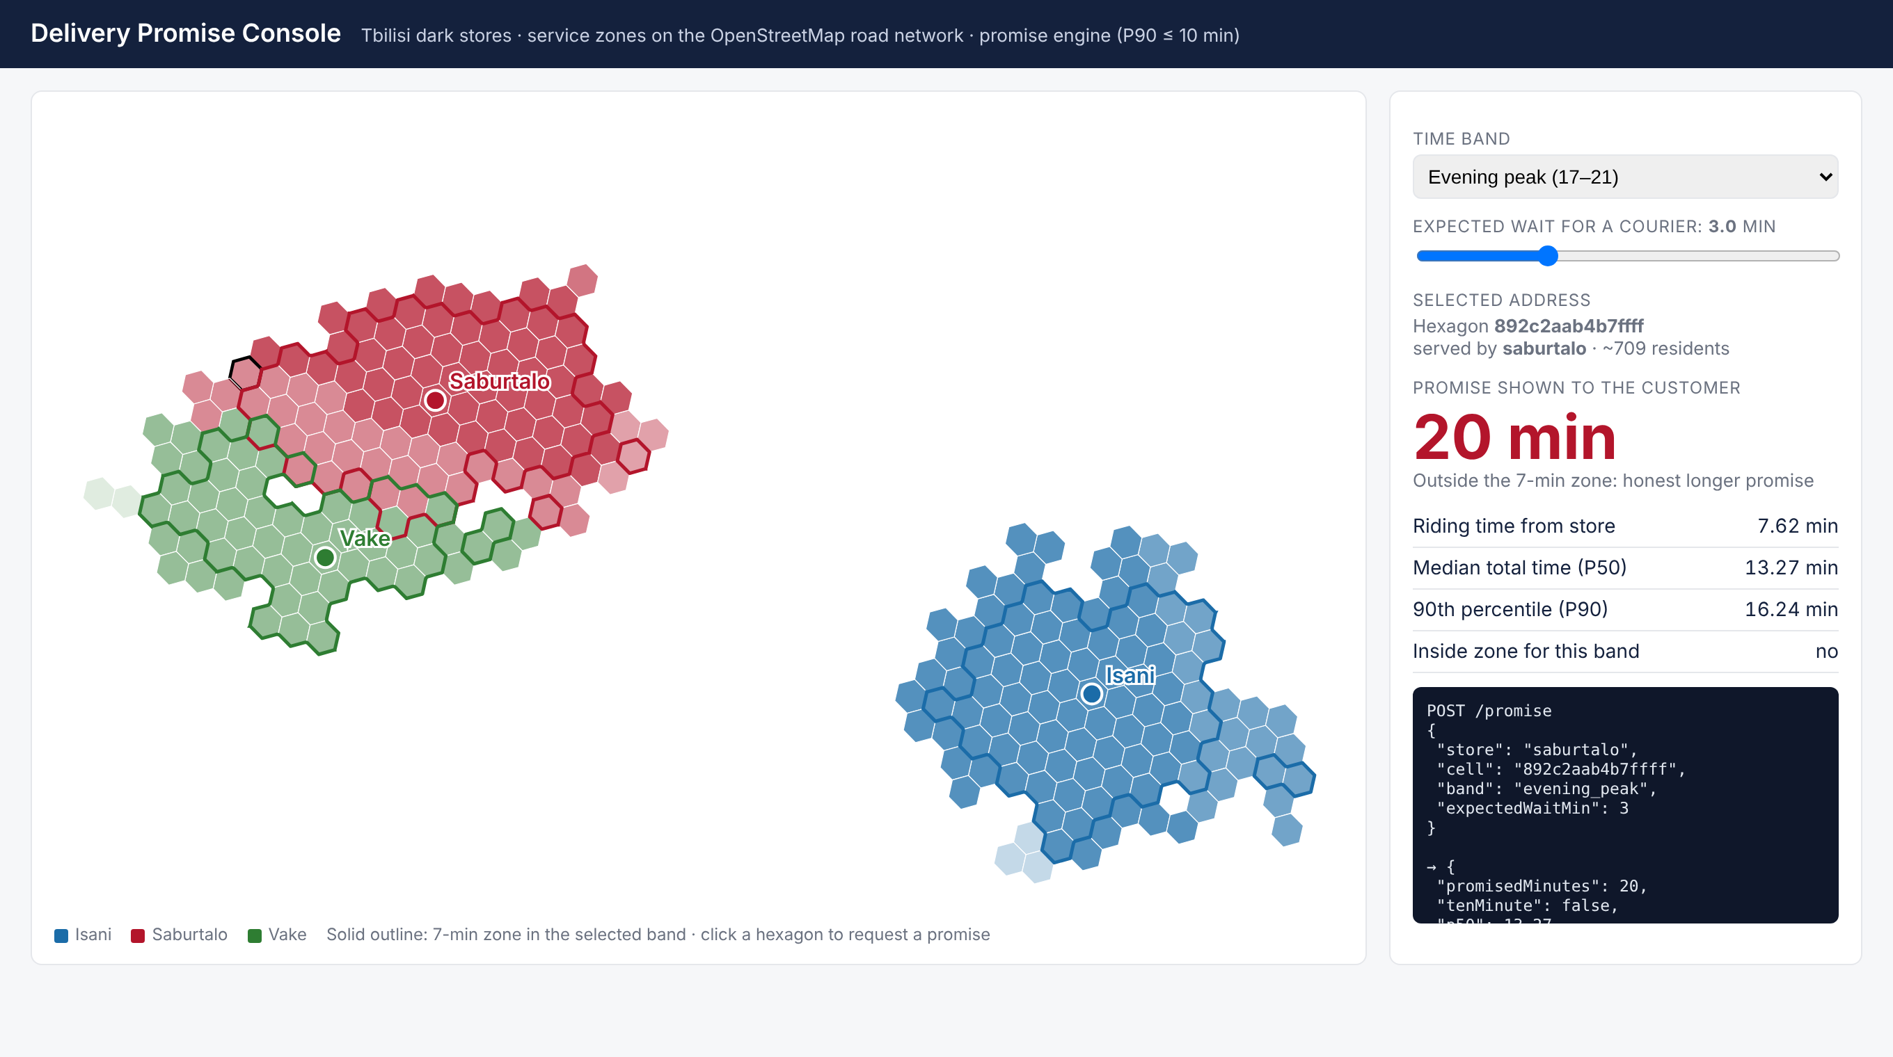
Figure N 6.
Demo console: an evening-peak request at the edge of the zone receives an honest 20-minute promise (screenshot, created by the author)

5.5 Order Allocation Algorithm and Solver
The allocation algorithm is split into two services. The Node.js allocation service, shown in Listing N 4, builds the cost matrix: for every pair of waiting order and available courier it predicts when the order would be delivered and turns this into a cost equal to the age of the order at delivery plus four times any minutes beyond its promise, and for every order it adds a defer column whose cost is the best cost the order could reach in the next round plus a penalty. The Python service, shown in Listing N 5, solves the matrix exactly with the linear sum assignment solver of Google OR-Tools. It converts the costs to integers, adds dummy rows so that a perfect matching exists, and returns for every order the chosen column, which is either a courier or the defer option.
Listing N 4.
Prediction of delivery times and construction of the cost matrix
// packages/allocation/src/assign.ts
export function predictedDelivery(o: Order, c: Courier,
now: number, band: string): number {
const start = Math.max(now, c.availableAt);
const transfer = c.store === o.store
? 0 : tt.storeToStore[band][c.store][o.store];
const pickup = Math.max(start + transfer, o.readyAt);
return pickup + tt.travel[band][o.store][o.cell]
+ PARAMS.handoverMin;
}
function score(o: Order, deliveredAt: number) {
const age = deliveredAt - o.placedAt;
return age
+ PARAMS.latePenalty * Math.max(0, age - o.promiseMin);
}
export function costMatrix(req: AssignRequest) {
const couriers = req.couriers.filter(
(c) => c.availableAt <= req.now + PARAMS.lookaheadMin);
const pairCost = (o: Order, c: Courier, at: number) => {
if (c.store !== o.store && tt.storeToStore[req.band]
[c.store][o.store] > PARAMS.maxTransferMin) return BIG;
return score(o, predictedDelivery(o, c, at, req.band))
+ (c.store !== o.store ? PARAMS.transferPenalty : 0);
};
const rows = req.orders.map((o, i) => {
const now = couriers.map((c) => pairCost(o, c, req.now));
// cost of deferring: best score one round later + penalty
const later = Math.min(...couriers.map(
(c) => pairCost(o, c, req.now + PARAMS.roundMin)), BIG);
const defer = req.orders.map((_, j) => (j === i
? (later < BIG ? later + PARAMS.deferPenalty : 0) : BIG));
return [...now, ...defer];
});
return { couriers, rows };
}
Source: packages/allocation/src/assign.ts in the project repository.
Listing N 5.
Exact assignment with Google OR-Tools
# solver/app.py
def solve(costs: list[list[float]], big: float = 1e6):
n_rows = len(costs)
if n_rows == 0:
return []
n_cols = len(costs[0])
if n_rows > n_cols:
raise ValueError("more rows than columns")
lsa = linear_sum_assignment.SimpleLinearSumAssignment()
for i, row in enumerate(costs):
for j, c in enumerate(row):
if c < big:
lsa.add_arc_with_cost(
i, j, int(round(c * SCALE)))
# dummy rows so that every column can be matched
for d in range(n_rows, n_cols):
for j in range(n_cols):
lsa.add_arc_with_cost(d, j, 0)
status = lsa.solve()
if status != lsa.OPTIMAL:
raise ValueError(f"no feasible assignment ({status})")
return [lsa.right_mate(i) for i in range(n_rows)]
Source: solver/app.py in the project repository.
Figure N 7 shows a sample input and the output of the allocation service. At 19:00 in the evening peak, three orders wait at the Isani store and two couriers are free. Order A was placed 5.5 minutes ago for an address 6.6 minutes away and can no longer be delivered within ten minutes; order B was placed 3.9 minutes ago and will just meet its ten-minute promise if it leaves now; order C was placed half a minute ago with a 15-minute promise. The service assigns A and B to the two couriers and leaves C for the next round, because C is the only order whose cost hardly grows if it waits thirty seconds. The last command calls the solver directly with a small matrix of two orders, one courier and two defer columns and shows the optimal assignment [0, 2]: the first order, for which waiting would be expensive, takes the courier, and the second order is deferred at a cost of 6.7 instead of 6.0, a total of 15.7 against 21.0 for the opposite choice.
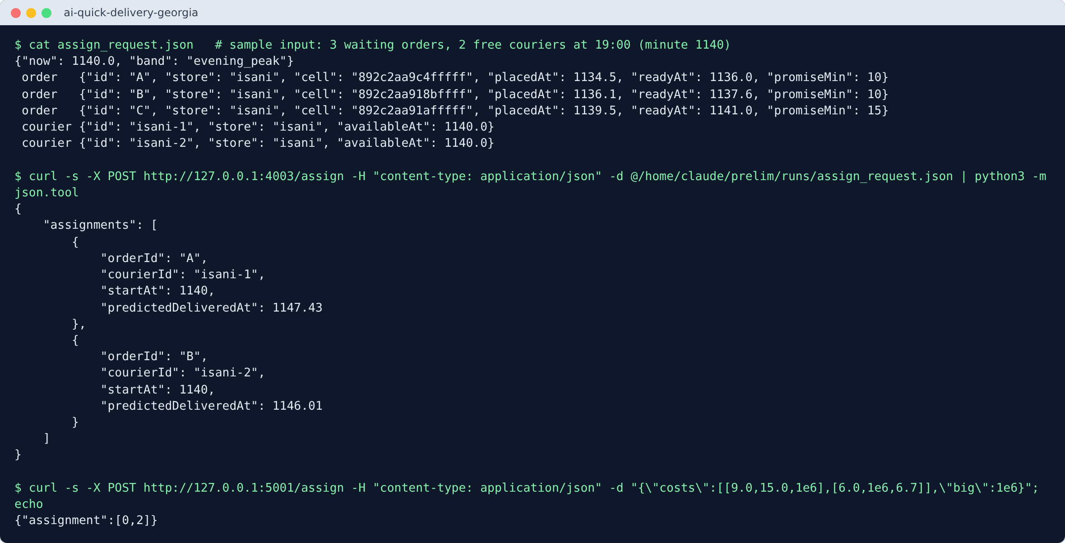
Figure N 7.
Sample input and output of the allocation service and a direct call of the OR-Tools solver (screenshot, created by the author)

5.6 Simulation Module
The simulator is written in Python with SimPy. Each simulated day starts with sampling the orders of every cell and slot from the scenario's expected demand and the picking and riding variations for each order, so that two policies run with the same seed face exactly the same day. Shift changes, order arrivals and allocation rounds are SimPy processes. Listing N 6 shows two of them. The trip function samples the whole trip once a courier is committed to an order, including a possible transfer to another store, the ride, the handover and the return. The allocator process implements the AI policy: every thirty simulated seconds it sends the waiting orders and available couriers to the allocation service over REST and starts the trips it receives. The baseline policy instead gives each ready order to the first free courier of its own store.
Listing N 6.
Trip sampling and the AI allocation process of the simulator
# simulator/sim.py (abridged; both functions are inside run())
def trip(c: Courier, o: Order, start: float):
"""Sample the whole trip once the courier is committed."""
b = band_for(start, weekend)
t = start
if c.home != o.store:
t += TT["storeToStore"][b][c.home][o.store]
depart = max(t, o.ready)
n_out, n_back, hand = ride_noise[o.id]
ride = TT["travel"][b][o.store][o.cell] * n_out
o.depart, o.delivered = depart, depart + ride + hand
back = TT["travel"][b][c.home][o.cell] * n_back
c.available_at = o.delivered + back
# ... courier statistics
return c.available_at

def allocator(): # AI policy: one round every 30 s
while env.now < end:
if waiting:
now, b = env.now, band_for(env.now, weekend)
cs = [c for c in couriers if c.active and not
c.retiring and c.available_at <= now + 2]
if cs:
payload = {"now": now, "band": b, "orders": [
{"id": o.id, "store": o.store,
"cell": o.cell, "placedAt": o.placed,
"readyAt": o.ready, "promiseMin": o.promise}
for o in waiting], "couriers": [
{"id": c.id, "store": c.home,
"availableAt": c.available_at} for c in cs]}
res = session.post(f"{ALLOC_URL}/assign",
json=payload).json()
for a in res["assignments"]:
o = by_o[a["orderId"]]
c = by_c[a["courierId"]]
ret = trip(c, o, max(now, c.available_at))
env.process(courier_returns(c, ret))
# ... remove the assigned orders from waiting
yield env.timeout(ROUND)
Source: simulator/sim.py in the project repository.
Figure N 8 shows two runs of the simulator on the match-day scenario with the same seed, so both runs contain the same 1,792 orders. With nearest-courier dispatch, 40.5 percent of the orders were delivered within ten minutes and 26.7 percent during the evening peak; with optimised assignment the shares rose to 63.1 and 51.8 percent, and the ninetieth-percentile delivery time fell from 28.2 to 19.8 minutes, while the mean delivery time and the courier hours stayed almost the same. Chapter 6 reports the averages over twenty such pairs for every scenario.
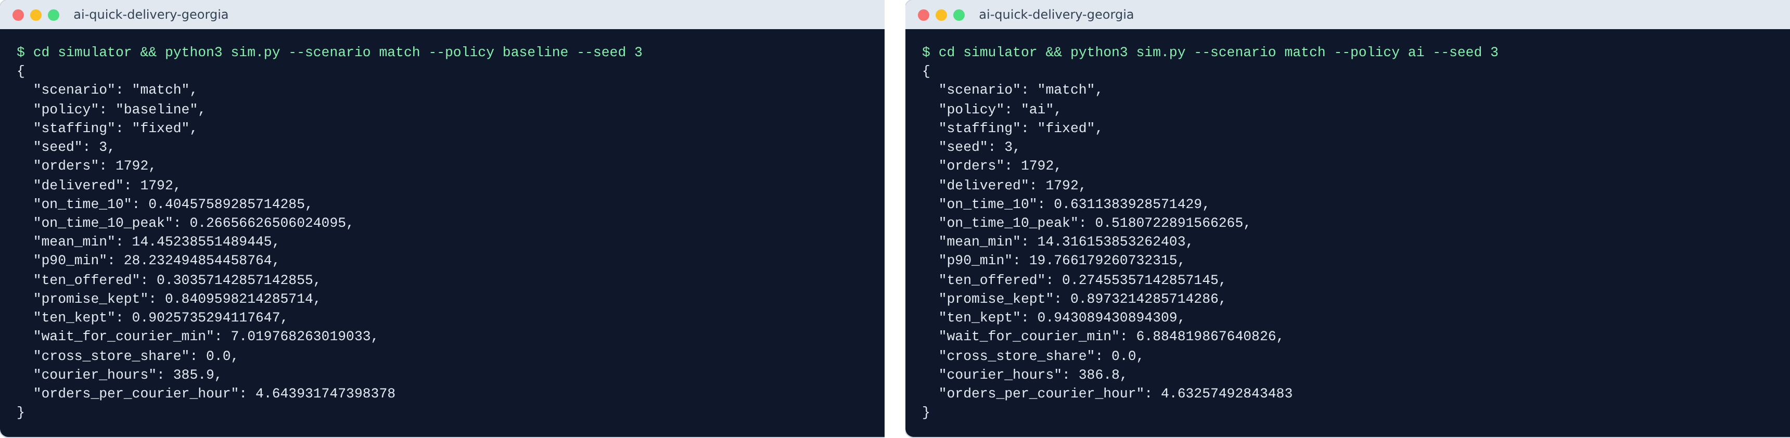
Figure N 8.
Two simulation runs of the match day with the same seed: nearest courier (left) and optimised assignment (right) (screenshot, created by the author)

5.7 Automated Tests
Automated tests check the behaviour of the two components whose correctness is easiest to state precisely. The tests of the promise engine, written with the Node.js test runner, check that a nearby address with a free courier receives the ten-minute promise, that a long expected wait removes it and rounds the promise up to a five-minute step, and that the same request always gives the same answer. The tests of the solver, written with pytest, check that scarce couriers go to the most urgent order and that a square assignment problem is solved with the minimum total cost. Figure N 9 shows that all five tests pass.
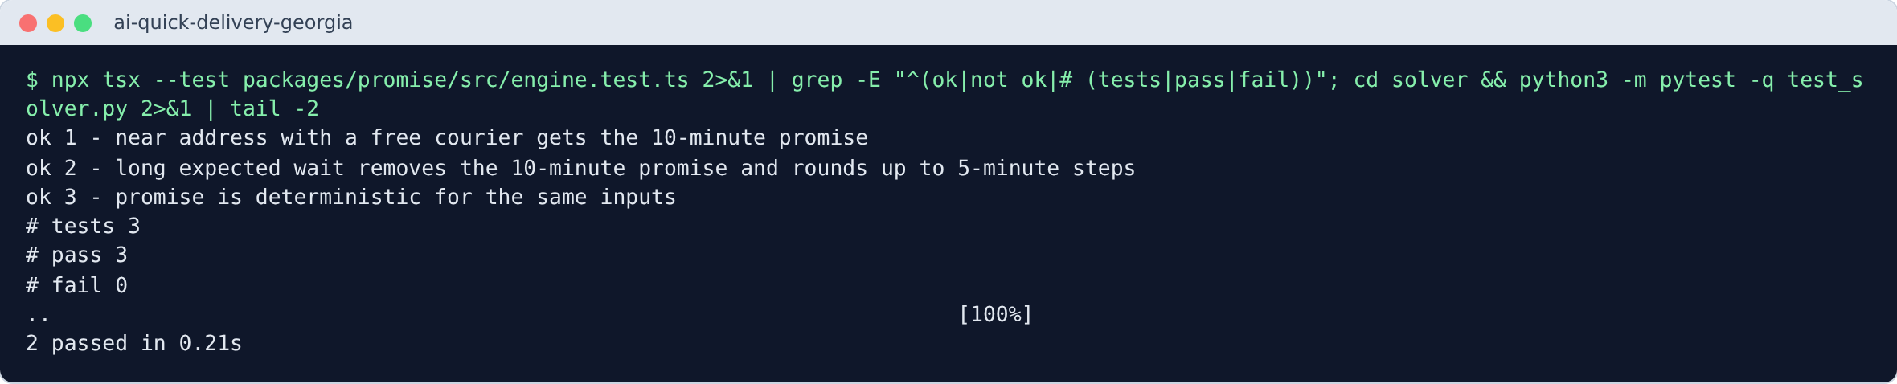
Figure N 9.
Automated tests of the promise engine and the assignment solver (screenshot, created by the author)

6. Interim Results

6.1 Service Zones and Dark-Store Siting
Figure N 10 shows the three dark stores chosen by the siting algorithm and their seven-minute zones on the road network of Tbilisi. The stores chosen by greedy maximum coverage together cover about 262,062 residents within seven minutes of riding at midday, compared with 164,327 for the locations chosen by hand at the concept stage, an increase of 59 percent with the same number of stores. Table N 6 lists the size of each zone. The zones confirm the role of the terrain that was discussed at the concept stage: the Isani zone extends over the flat street grid on the left bank of the Mtkvari, while the zones of Saburtalo and especially Vake are cut short by the hills to the west and by the slow, winding streets that climb them.
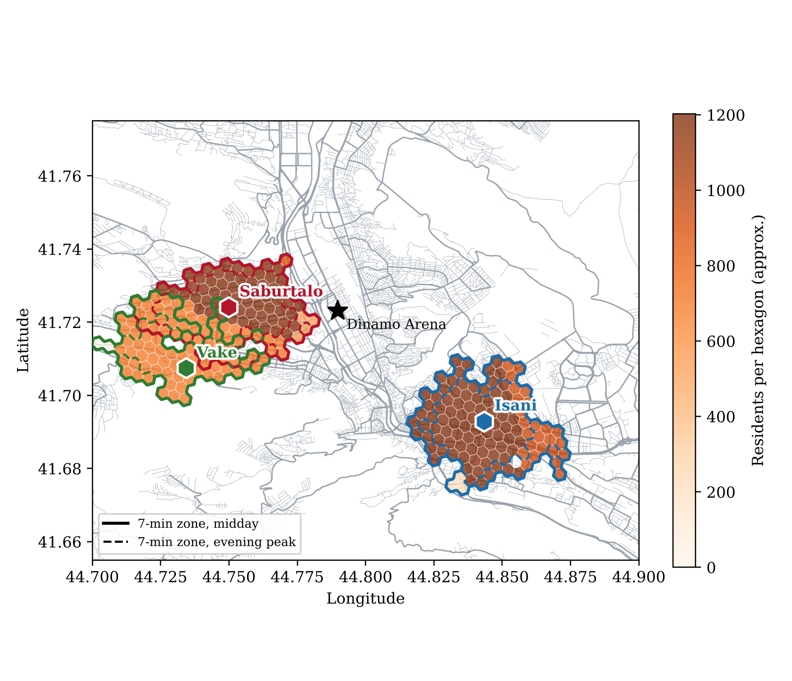
Figure N 10.
Dark stores chosen by maximum coverage and their 7-minute riding zones on the OpenStreetMap road network of Tbilisi (created by the author)
Table N 6.
Seven-minute zones per dark store, midday / evening peak
Dark store | H3 cells | Residents (approx.) | Area (km²)
Isani | 112 / 67 | 125,273 / 77,979 | 11.9 / 7.1
Saburtalo | 110 / 70 | 105,603 / 71,455 | 11.7 / 7.4
Vake | 78 / 46 | 54,826 / 32,604 | 8.3 / 4.9
Source: created by the author from the OpenStreetMap road network; residents are approximated from district populations.
Because the evening peak is assumed to be thirty percent slower, every zone shrinks in the evening by 36 to 41 percent of its area. Together the midday zones contain about 285,702 residents counted per store, where overlapping cells between Saburtalo and Vake are served by the nearer store. Addresses outside the current zone still receive deliveries, but with an honest longer promise.

6.2 Demand Forecasting
Table N 7 compares the TensorFlow.js forecaster with the seasonal naive forecast over the three test weeks. At the level of store and hour, which is the level used for staffing, the weighted absolute percentage error of the network is 16.4 percent against 21.7 percent for the naive forecast, a reduction of 24 percent. The reduction is 27 percent on normal days and 12 percent on match days. The model trained in 216 seconds on 960,512 observations with the pure JavaScript backend. At the level of a single hexagon and fifteen-minute slot the errors of both methods are very high, because most slots contain zero or one order, so this level is not used for decisions.
Table N 7.
Forecast error (WAPE) by store and hour, test period 6 to 26 October 2025
Days | Neural network | Seasonal naive | Reduction
All test days | 16.4% | 21.7% | 24%
Normal days | 15.9% | 21.8% | 27%
Match days | 18.9% | 21.6% | 12%
Source: created by the author; WAPE = sum of absolute errors divided by the sum of actual orders.
Figure N 11 shows two test days. On the normal weekday the network follows the daily shape more smoothly than the naive forecast, which repeats last week's random fluctuations. On the match day the network anticipates the rise before kick-off but underestimates the peak, while the naive forecast happens to perform well because the previous Wednesday also had an evening national-team match. Over the whole test period the network underestimates total demand by about two percent and evening demand by about four percent, a small bias that the final model should correct.
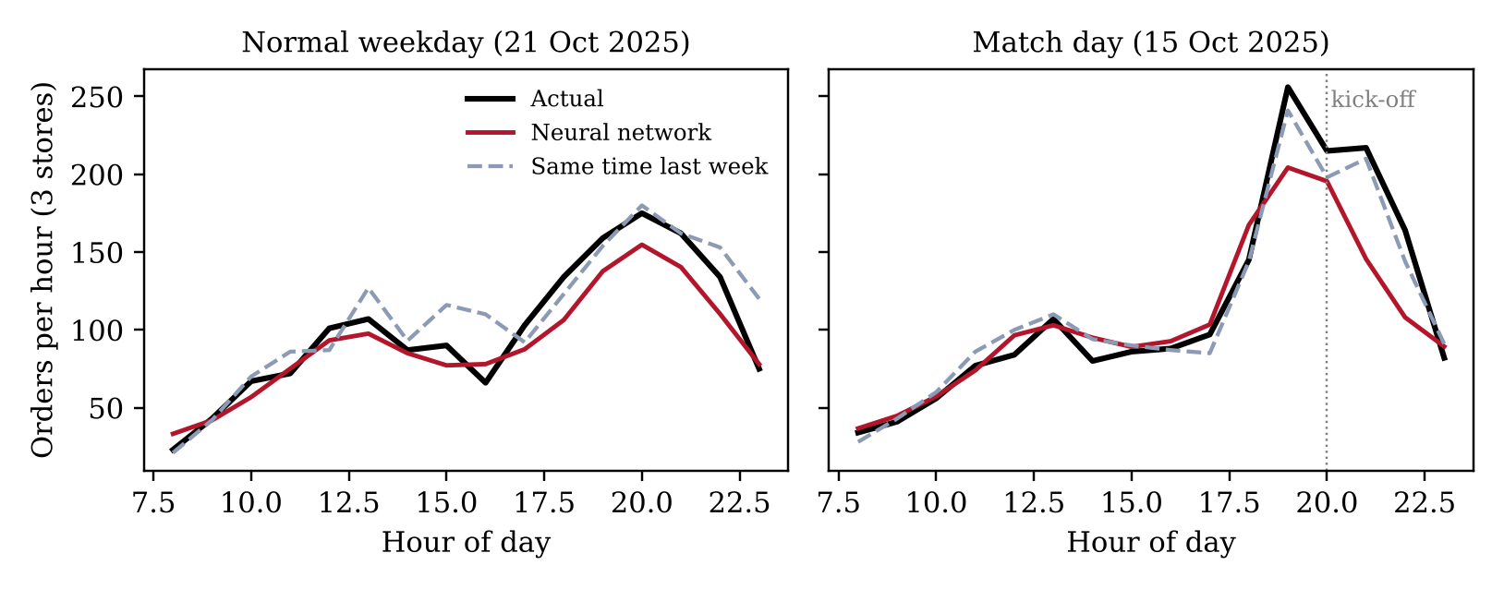
Figure N 11.
Hourly orders of the three stores: actual demand, neural network forecast and seasonal naive forecast (created by the author)

6.3 Optimised Assignment Compared with Nearest-Courier Dispatch
Table N 8 and Figure N 12 summarise experiment one. With identical orders and couriers, the optimised assignment delivered a higher share of orders within ten minutes than the nearest-courier baseline in all four scenarios and in all 20 paired runs of each scenario. On the normal weekday the share rose from 75.3 to 78.9 percent and on Saturday from 78.3 to 82.6 percent, while the ninetieth-percentile delivery time fell by about one minute. The mean delivery time did not change, which shows that the gain comes from the order in which couriers serve waiting orders: the solver gives priority to orders that are close to their promise.
Table N 8.
Orders delivered within 10 minutes, nearest courier vs optimised assignment (20 paired runs)
Scenario | Orders | Baseline | Optimised | Difference (pp) | P90 (min)
Weekday | 1,503 | 75.3% | 78.9% | +3.6 ± 1.1 | 12.5 → 11.7
Saturday | 1,898 | 78.3% | 82.6% | +4.3 ± 1.2 | 12.2 → 11.3
Rainy weekday | 1,921 | 36.0% | 61.0% | +25.0 ± 2.0 | 56.2 → 41.4
Match day | 1,760 | 50.4% | 67.5% | +17.1 ± 2.6 | 27.6 → 17.8
Source: created by the author; ± is the 95% confidence interval of the paired difference; P90 is the 90th-percentile delivery time, baseline → optimised.
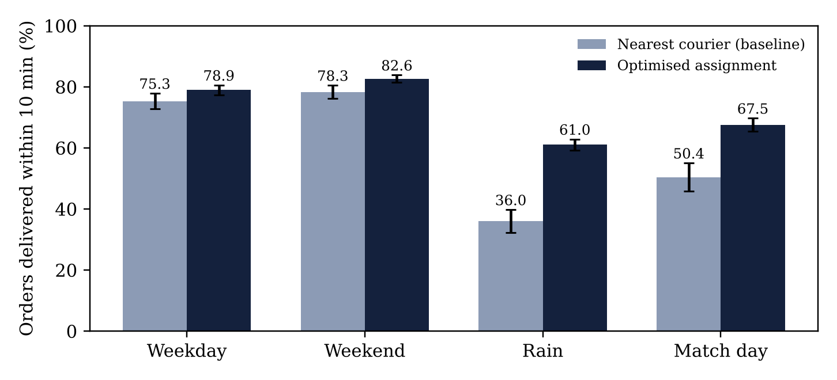
Figure N 12.
Share of orders delivered within 10 minutes by dispatch policy, with 95% confidence intervals (created by the author)
The differences are much larger on the rainy day (+25.0 percentage points) and on the match day (+17.1 points). On these days demand exceeds the capacity of a staffing plan based on an average day: on the rainy day couriers were waited for 15.7 minutes on average and the mean delivery time was 23.0 minutes under both policies. The optimised assignment cannot create capacity; it keeps more promises by serving first the orders that can still arrive on time, which reduced the ninetieth-percentile delivery time from 56.2 to 41.4 minutes. The ten-minute promise was offered to about 54 percent of orders on the normal weekday and 24 percent on the rainy day, and it was kept in 96 and 95 percent of cases respectively, which shows that the promise engine adapts its promises to the situation. No courier was sent to another store, because the stores are more than six minutes apart.

6.4 Forecast-Driven Staffing
Table N 9 summarises experiment three. With the same total courier hours, staffing planned from the forecast raised the share of orders delivered within ten minutes during the evening peak from 46.8 to 53.6 percent on the rainy day and from 54.7 to 66.1 percent on the match day. Over the whole day, however, the effect was 0.1 points on the rainy day and -2.3 points on the match day, because the couriers added to the peak were taken from other hours that were already busy.
Table N 9.
Fixed vs forecast-driven staffing with the same courier hours (optimised assignment, 20 paired runs)
Scenario | Peak, fixed | Peak, forecast | Day, fixed | Day, forecast
Rainy weekday | 46.8% | 53.6% | 61.0% | 61.1%
Match day | 54.7% | 66.1% | 67.5% | 65.3%
Source: created by the author; peak = orders placed 17:00–21:00; values are shares of orders delivered within 10 minutes.
This result shows that forecasting is most useful for deciding when capacity is needed, but that on days with unusually high demand the planner must also be allowed to add courier hours, which is a cost decision for the operator. The final version of the event-aware planner will therefore compare plans with additional hours and report the cost of each extra percentage point of on-time deliveries.

6.5 Status of the Hypotheses
The first hypothesis is supported by the preliminary results: optimised assignment outperformed nearest-courier dispatch in every scenario and in every paired run, by 3.6 to 25.0 percentage points. The second hypothesis is supported at the level of store and hour, with a 24 percent lower error than the seasonal naive forecast, but the advantage on match days rests on only two test days. The third hypothesis is partly supported: forecast-driven staffing improved the evening peak considerably without additional hours or faster riding, but not the whole day. All results depend on synthetic orders and on assumed congestion factors, and they show how the methods behave under the stated assumptions rather than how a real service would perform; the final stage will test their sensitivity to these assumptions.

7. Remaining Work
The remaining work until the final defence follows from the limitations of the prototype. First, travel times will be calibrated with traffic-aware times from the Google Maps Platform Routes API for each store, cell and time band, cached as described in the design, and elevation data will be added so that uphill riding is slower than downhill riding. Second, the allocation service will bundle two orders for one courier when a route with time windows confirms that both promises still hold. Third, the delivery-fee rule of the event planner will be implemented with a fixed cap and shown to customers before checkout. Fourth, the core backend will be built with Node.js, Express, PostgreSQL and PostGIS, including stock reservation in transactions and live tracking with Socket.IO, together with the customer application, the courier application and the operations dashboard in React. Fifth, the experiments will be extended with sensitivity analysis of demand, picking times and congestion factors, and with live courier GPS feedback in the simulation.
Table N 10.
Plan until the final defence
Period | Planned work
December 2026 | Google Routes API calibration, elevation data, order batching
January 2027 | Backend with PostgreSQL and PostGIS; event planner fee rule
February 2027 | Customer and courier applications, operations dashboard
March 2027 | Extended experiments and sensitivity analysis; final thesis of at least 30 pages, user guide and defence
Source: created by the author; dates will follow the official deadlines of the school.

Conclusion
This preliminary report has presented the technical design and the first working prototype of an AI-powered quick food delivery system for Tbilisi. Service zones are polygons, as in Zepto's operations, but they are generated from the real road network of Tbilisi, and dark-store locations are chosen by maximum coverage. Demand is forecast per H3 hexagon with a TensorFlow.js network that uses real weather, holidays and football matches, the promise engine offers ten minutes only when the ninetieth percentile fits, and orders are assigned every thirty seconds with Google OR-Tools. The components run as JavaScript and Python services and are evaluated in a SimPy simulation that calls the services themselves. The software is implemented, not only designed: the report shows the source code of each main component, its execution on sample inputs with the resulting outputs, and passing automated tests, and the complete code can be built and run from the project repository with the documented commands. The first results support the direction of the project while showing honestly where the effects are small and where the assumptions still need real data. The final stage will add traffic-aware travel times, batching, the database and the applications, so that the prototype becomes a complete product.

References
Banga, J. (2026, April 9). Mapping India’s hidden 10-minute grocery warehouses. HackerNoon. Retrieved October 26, 2026, from https://hackernoon.com/mapping-indias-hidden-10-minute-grocery-warehouses
Brinkhoff, T. (n.d.). Tbilisi (city, Georgia): Districts. City Population. Retrieved November 11, 2026, from https://citypopulation.de/en/georgia/tbilisicity/
Brodsky, I. (2018, June 27). H3: Uber’s hexagonal hierarchical spatial index. Uber Engineering Blog. Retrieved October 26, 2026, from https://www.uber.com/en/blog/h3/
Castillo, J. C., Knoepfle, D., & Weyl, E. G. (2017). Surge pricing solves the wild goose chase. In Proceedings of the 2017 ACM Conference on Economics and Computation (pp. 241–242). Association for Computing Machinery. https://doi.org/10.1145/3033274.3085098
CBW. (n.d.-a). First dark store of Glovo appears in Tbilisi. Retrieved October 26, 2026, from https://cbw.ge/business/first-dark-store-of-glovo-appears-in-tbilisi
CBW. (n.d.-b). Connie Kwok, VP of Q-Commerce at Glovo: “Quick commerce is the future of shopping in Georgia”. Retrieved October 26, 2026, from https://www.cbw.ge/business/connie-kwok-vp-of-q-commerce-at-glovo-quick-commerce-is-the-future-of-shopping-in-georgia
Church, R., & ReVelle, C. (1974). The maximal covering location problem. Papers of the Regional Science Association, 32(1), 101–118. https://doi.org/10.1007/BF01942293
Derrow-Pinion, A., She, J., Wong, D., Lange, O., Hester, T., Perez, L., Nunkesser, M., Lee, S., Guo, X., Wiltshire, B., Battaglia, P. W., Gupta, V., Li, A., Xu, Z., Sanchez-Gonzalez, A., Li, Y., & Veličković, P. (2021). ETA prediction with graph neural networks in Google Maps. In Proceedings of the 30th ACM International Conference on Information and Knowledge Management (pp. 3767–3776). Association for Computing Machinery. https://doi.org/10.1145/3459637.3481916
Dijkstra, E. W. (1959). A note on two problems in connexion with graphs. Numerische Mathematik, 1, 269–271. https://doi.org/10.1007/BF01386390
Entrepreneur Georgia. (2025, July 12). Mravalperovani produkti da mudmivad akhali khil-bostneuli: Wolt Market-ma me-7 piliali Gldanshi gakhsna [Diverse products and constantly fresh fruit and vegetables: Wolt Market opened its 7th branch in Gldani]. Entrepreneur Georgia. Retrieved October 26, 2026, from https://www.entrepreneur.com/ka/business-news/mravalferovani/494564
Geofabrik. (2026). Georgia OpenStreetMap data extract [Data set]. Retrieved November 11, 2026, from https://download.geofabrik.de/europe/georgia.html
Geostat. (2026). Number of population as of January 1, 2026. National Statistics Office of Georgia. Retrieved October 26, 2026, from https://geostat.ge/media/78328/Number-of-Population-as-of-January-1%2C-2026.pdf
Google. (n.d.). Get a route matrix: Routes API. Google Maps Platform. Retrieved October 26, 2026, from https://developers.google.com/maps/documentation/routes/compute_route_matrix
Gorkhelashvili, M. (2023, July 11). Glovo expands in Georgian market with new locations. Georgia Today. Retrieved October 26, 2026, from https://georgiatoday.ge/glovo-expands-in-georgian-market-with-new-locations
Haklay, M., & Weber, P. (2008). OpenStreetMap: User-generated street maps. IEEE Pervasive Computing, 7(4), 12–18. https://doi.org/10.1109/MPRV.2008.80
Hevner, A. R., March, S. T., Park, J., & Ram, S. (2004). Design science in information systems research. MIS Quarterly, 28(1), 75–105. https://doi.org/10.2307/25148625
Hyndman, R. J., & Athanasopoulos, G. (2021). Forecasting: Principles and practice (3rd ed.). OTexts. Retrieved October 26, 2026, from https://otexts.com/fpp3/
Ke, G., Meng, Q., Finley, T., Wang, T., Chen, W., Ma, W., Ye, Q., & Liu, T.-Y. (2017). LightGBM: A highly efficient gradient boosting decision tree. In Advances in Neural Information Processing Systems 30 (pp. 3146–3154). Curran Associates.
Kuhn, H. W. (1955). The Hungarian method for the assignment problem. Naval Research Logistics Quarterly, 2(1–2), 83–97. https://doi.org/10.1002/nav.3800020109
Law, A. M. (2015). Simulation modeling and analysis (5th ed.). McGraw-Hill Education.
McKinsey & Company. (2022, August 17). Quick commerce pushes the limits on grocery delivery [Podcast transcript]. Retrieved October 26, 2026, from https://www.mckinsey.com/industries/technology-media-and-telecommunications/our-insights/quick-commerce-pushes-the-limits-on-grocery-delivery
Nanwani, K., Raj, A., & Prabhu, G. N. (2022, December 21). Quick commerce last mile delivery: Indispensable or superfluous? Forbes India. Retrieved October 26, 2026, from https://www.iimb.ac.in/sites/default/files/2022-12/Quick-commerce-last-mile-delivery_%20Indispensable.pdf
Outlook Business. (2026, January 13). Quick-commerce giants drop ‘10-minute delivery’ promise after govt intervention. Outlook Business. Retrieved October 26, 2026, from https://www.outlookbusiness.com/start-up/e-commerce/quick-commerce-giants-drop-10-minute-delivery-promise-after-govt-intervention
Perron, L., & Furnon, V. (2024). OR-Tools [Computer software]. Google. Retrieved October 26, 2026, from https://developers.google.com/optimization/
Pillac, V., Gendreau, M., Guéret, C., & Medaglia, A. L. (2013). A review of dynamic vehicle routing problems. European Journal of Operational Research, 225(1), 1–11. https://doi.org/10.1016/j.ejor.2012.08.015
Reyes, D., Erera, A., Savelsbergh, M., Sahasrabudhe, S., & O’Neil, R. (2018). The meal delivery routing problem. Optimization Online. Retrieved October 26, 2026, from https://optimization-online.org/2018/04/6571/
Rodrigues, F., Markou, I., & Pereira, F. C. (2019). Combining time-series and textual data for taxi demand prediction in event areas: A deep learning approach. Information Fusion, 49, 120–129. https://doi.org/10.1016/j.inffus.2018.07.007
Smilkov, D., Thorat, N., Assogba, Y., Nicholson, C., Kreeger, N., Yu, P., Cai, S., Nielsen, E., Soegel, D., Bileschi, S., Terry, M., Yuan, A., Zhang, K., Gupta, S., Sirajuddin, S., Sculley, D., Monga, R., Corrado, G., Viégas, F., & Wattenberg, M. (2019). TensorFlow.js: Machine learning for the web and beyond. Proceedings of Machine Learning and Systems, 1, 309–321.
Taylor, S. J., & Letham, B. (2018). Forecasting at scale. The American Statistician, 72(1), 37–45. https://doi.org/10.1080/00031305.2017.1380080
Team SimPy. (n.d.). SimPy: Discrete event simulation for Python [Computer software]. Retrieved October 26, 2026, from https://simpy.readthedocs.io/
Toth, P., & Vigo, D. (Eds.). (2014). Vehicle routing: Problems, methods, and applications (2nd ed.). Society for Industrial and Applied Mathematics.
Ulmer, M. W., Thomas, B. W., Campbell, A. M., & Woyak, N. (2021). The restaurant meal delivery problem: Dynamic pickup and delivery with deadlines and random ready times. Transportation Science, 55(1), 75–100. https://doi.org/10.1287/trsc.2020.1000
Xu, Z., Li, Z., Guan, Q., Zhang, D., Li, Q., Nan, J., Liu, C., Bian, W., & Ye, J. (2018). Large-scale order dispatch in on-demand ride-hailing platforms: A learning and planning approach. In Proceedings of the 24th ACM SIGKDD International Conference on Knowledge Discovery and Data Mining (pp. 905–913). Association for Computing Machinery. https://doi.org/10.1145/3219819.3219824
Yang, X., Ostermeier, M., & Hübner, A. (2024). Winning the race to customers with micro-fulfillment centers: An approach for network planning in quick commerce. Central European Journal of Operations Research, 32(2), 295–334. https://doi.org/10.1007/s10100-023-00893-x
Zippenfenig, P. (2023). Open-Meteo.com weather API [Computer software]. Zenodo. https://doi.org/10.5281/ZENODO.7970649

